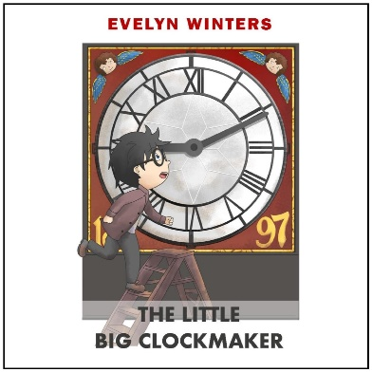
Writing Book Reviews
Writing a book review gives a useful insight into whether the book is worth reading. This guide will help to construct a helpful review.
Read ‘The Little Big Clockmaker’ which can be DOWNLOADED for free on my website and then write an honest review.
This document does not need to be printed and can be filled in as part of an IT lesson. This a guide will help you build your book review:
- What was the story about? (give a brief outline of the plot but never reveal the ending!)
Click or tap here to enter text.

- Mention the book's genre.
Click or tap here to enter text.

- What did you think about the title?
Click or tap here to enter text.

- Who was the main character and what did they do?
Click or tap here to enter text.

- Who were the other important characters?
Click or tap here to enter text.

- Were the characters believable?
Click or tap here to enter text.

- Who was your favourite and why?
Click or tap here to enter text.

- Could you relate to any of the characters in the story?
Click or tap here to enter text.

- Have you ever done or felt some of the things, the characters did?
Click or tap here to enter text.

- Did you like the book - was it professionally written?
Click or tap here to enter text.

- Did you have a favourite part of the book?
Click or tap here to enter text.

- Do you have a least favourite part of the book?
Click or tap here to enter text.

- Would you change anything in the story?
Click or tap here to enter text.

- Would you recommend this book to another person? if yes tell us why. If no tell us why.
Click or tap here to enter text.

- What type of person would like this book?
Click or tap here to enter text.

